Needville Harvest Festival, Inc 3K Fun Run

WHEN: October 16, 2021
WHERE: The Needville Elementary Campus
Event starts @ 7:30 a.m.
Meet by 7:00 a.m. for pre-event staging

Deadline for entries is
October 16, 2021 (you can register at the event)

Your collection of donations will go to the 2021 Needville Harvest Festival, Inc Scholarships.

All participants collecting $20.00 or more will receive a commemorative T-shirt.*

Don’t miss this event!
______________________________________
A prize will be awarded to the participant with the largest donation total. The Race Winner will receive a trophy.

Get your sponsor sign-up sheet today!

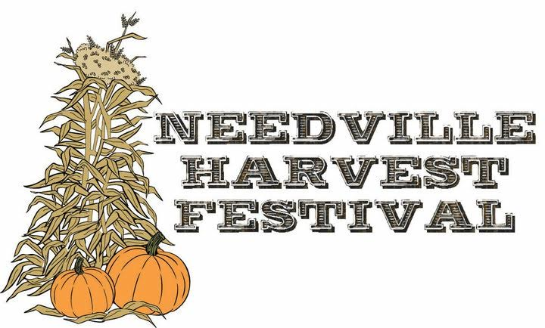
Contact Adam Kohleffel at Kohleffela@needvilleisd.com for more info or to get a collection sheet.

Needville Harvest Festival, Inc Scholarships - 3K Fun Run!
October 16, 2021
*All participants collecting $20.00 or more will receive a Commemorative T-shirt. Deadline for entries is the day of the event. Event Starts @ 7:30 a.m. Meet @ Needville Elementary School playground. If the inventory of shirt runs out, shirts will be delivered or picked-up at a later date.
Turn this page in at the race with any donations collected.

Name Donation Amount
________________________________________________ ________________________________________________ ________________________________________________ ________________________________________________ ________________________________________________ ________________________________________________ ________________________________________________ ________________________________________________ ________________________________________________ ________________________________________________ ________________________________________________ ________________________________________________ ________________________________________________ ________________________________________________ ________________________________________________

